**Name:**

**Advanced Programming in Java**

**Lab Exercise 6.5.2025**

**Introduction to Java**

In this lab you will be introduced to programming in the Java Development environment. Java was developed by Sun Microsystems. Java is both a compiled and interpreted language. Program code is written via a text editor to create a .java file. The .java file is sent to the java compiler which converts it into a binary .class file. This .class file is sent to the Java Interpreter which runs the program. This .class file is binary object code and cannot be viewed. It is in the form of bytecode which is platform independent.

Before we start, there are a couple of DOS commands you should be familiar with. You can open the console window by running cmd.

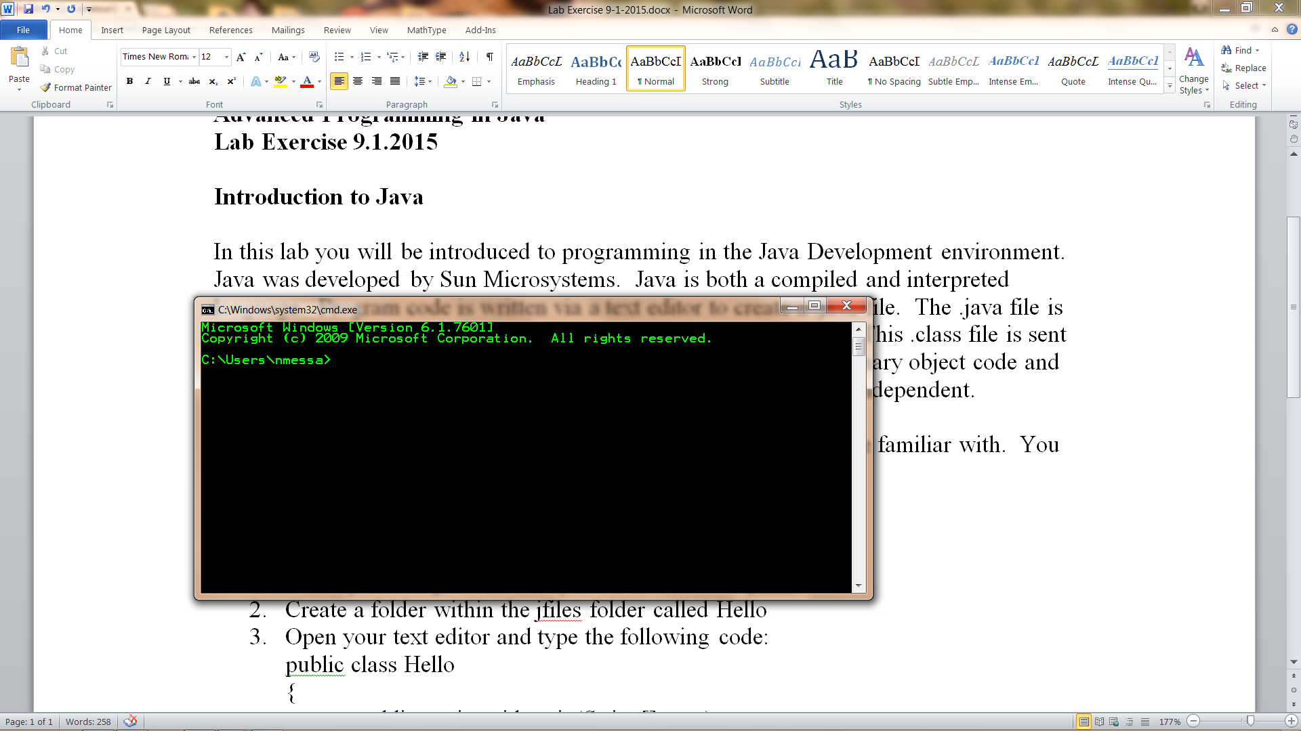

|  |  |
| --- | --- |
| cd.. | moves you up one level |
| cd\ | takes you to root directory |
| cd *directoryName* | Change directory to subdirectory |
| md *directoryName* | creates a new directory |
| rd *directoryName* | removes a directory |
| dir | gives a listing of the current directory |
| dir/w | gives a wide version of the directory |
| del*filename* | deletes a file |
| del *.* | deletes all files in the current directory |

1. Start by creating a folder on your C drive called jfiles.
2. Create a folder within the jfiles folder called Hello
3. Open your text editor and type the following code:

public class Hello

{

public static void main(String[] args)

{

System.out.println(“Hello World”);

}

}

1. Save the file in the C:\jfiles\Hello folder under the name Hello.java (case sensitive). In the File Save Dialog be sure to select the *.* all files filter.
2. Open the command prompt and navigate the C:\jfiles\Hello folder.
3. At the C:\jfiles\Hello prompt type

javac Hello.java

1. Get a directory to verify the Hello.class file has been created
2. Type the following at the C:\jfiles\Hello prompt

java Hello

1. You should get the message “Hello World” on your console.
2. Now write a program that prints your name, address, city, state, zip, area code, and phone number.
3. Write a program that will print the numbers from 1 to 10 and their square, cube, and square root.

Syntax for loop:

for (int i = 1; i <= 10; i++)

{

//Add code here

}

Some useful math functions:

Math.pow(2, 5) returns 32.0

Math.sqrt(4) returns 2.0

**Creating Basic Java Application Projects with JCreator**

In this course we will be creating projects for each program that we write.

1. Create a folder on your desktop called MyJava
2. Start JCreator (we are using version 4.5)
3. Select File|New|Project from the menu which will start the Project Wizard.

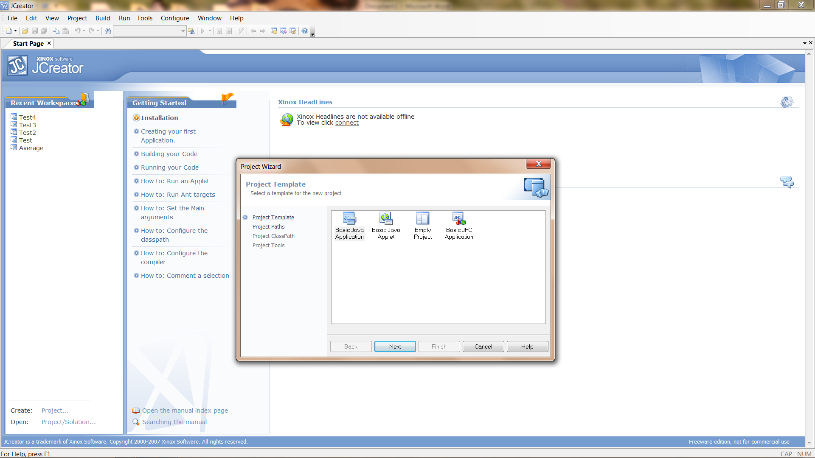

1. Select Basic Java Application Project and click Next.

Enter the Project name and navigate to the MyJava folder on your desktop. I used Hello.

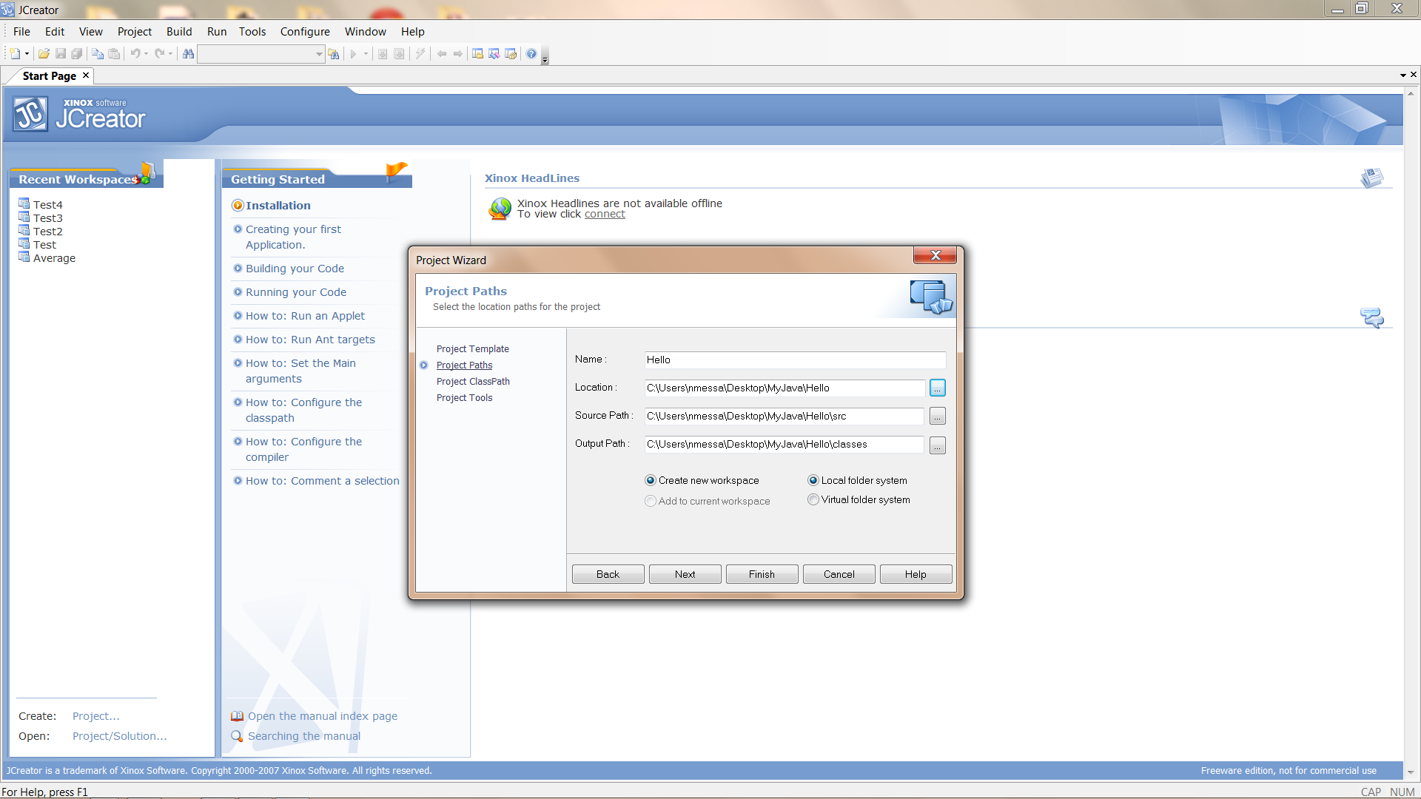

1. Click Next

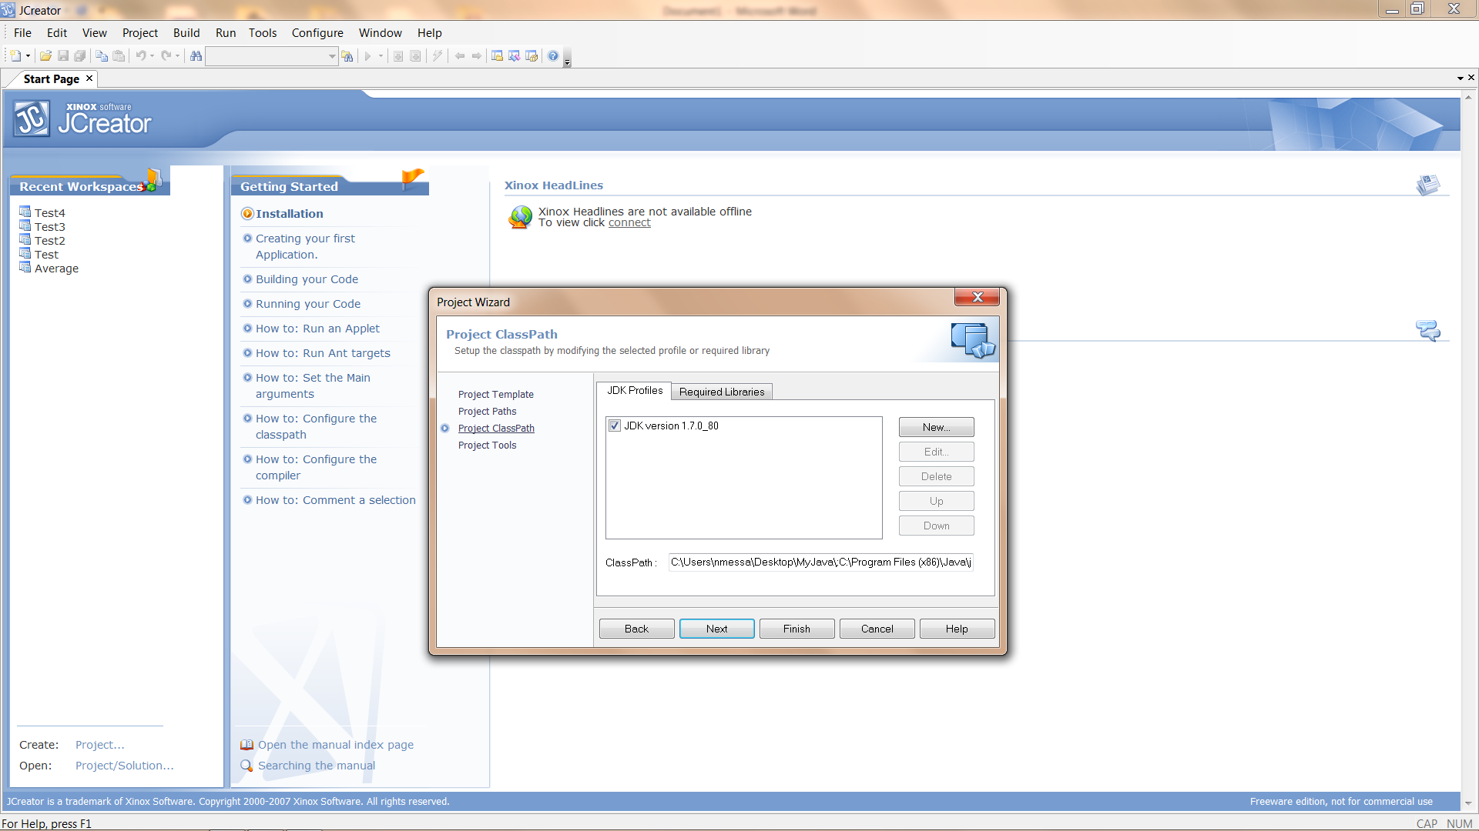

1. Click Next

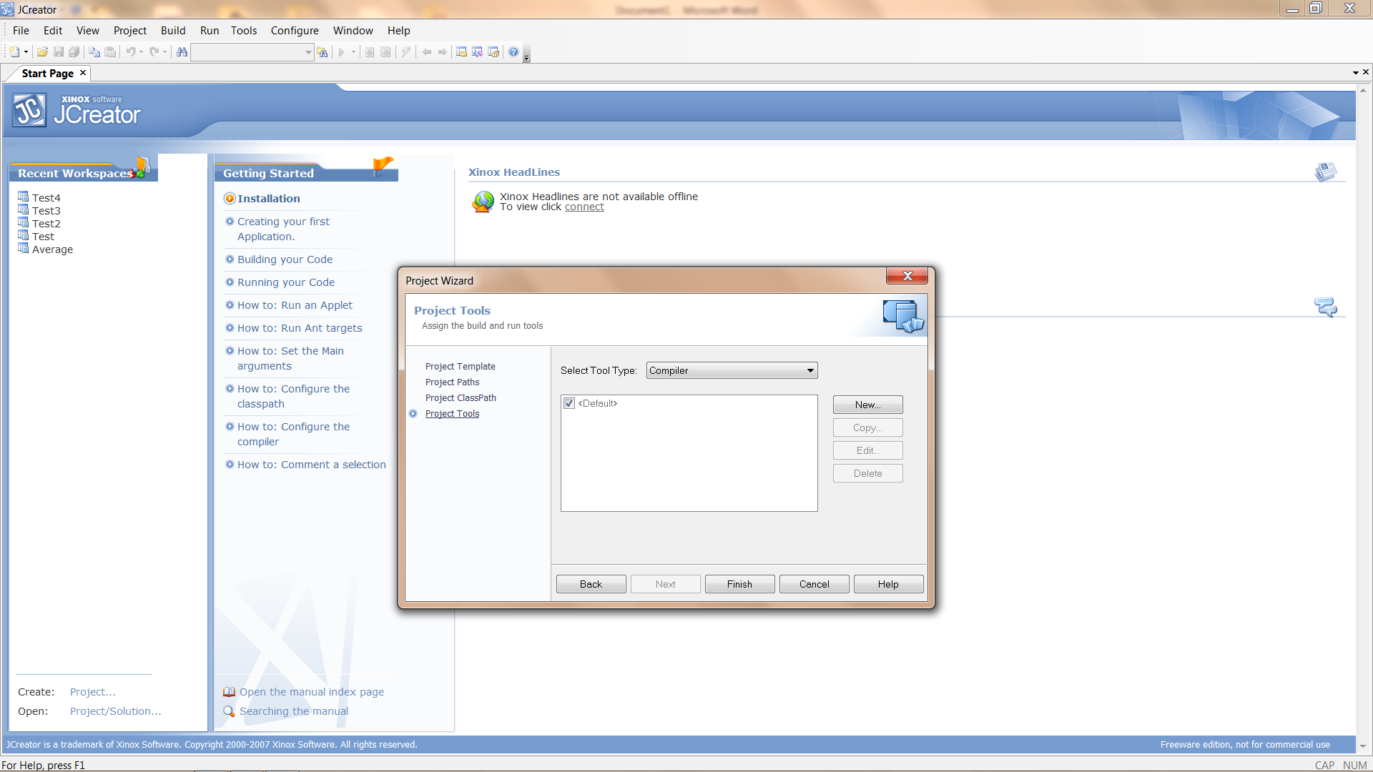

1. Click Finish

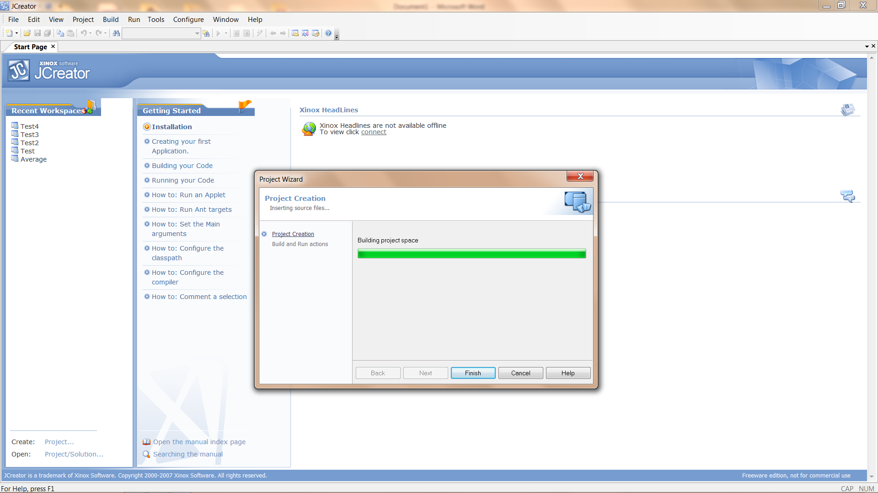

1. When the project has completed building, click Finish

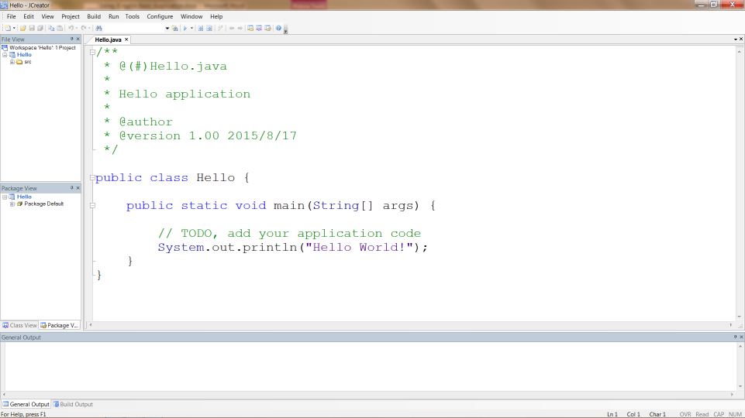

At this point we have a Basic Java Project which includes a Class Hello with a main method that will print “Hello World!” to the console. If you look inside the Hello folder (inside the MyJava folder) you will see 3 files (Hello.jcp, Hello.jcu, and Hello.jcw) and 2 folders (src and classes).

1. Click on the Run Project button and you should get a Process Complete message.

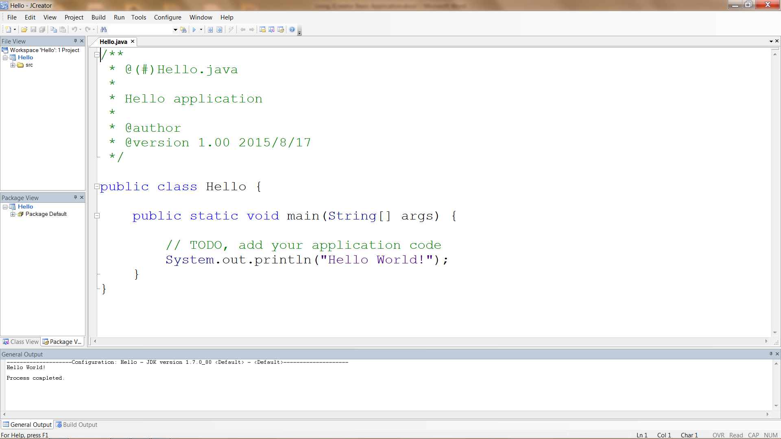

1. Now take a look in the MyJava\Hello folder. You should see Hello.java inside the src folder and Hello.class inside the classes folder.

**Creating Empty Java Projects with JCreator**

In this course we will be creating projects for each program that we write.

1. Create a folder on your desktop called MyJava
2. Start JCreator (we are using version 4.5)
3. Select File|New|Project from the menu which will start the Project Wizard.



1. Select Empty Project and click Next.

Enter the Project name and navigate to the MyJava folder on your desktop. Add a folder (inside MyJava) for your project. I used Hello.

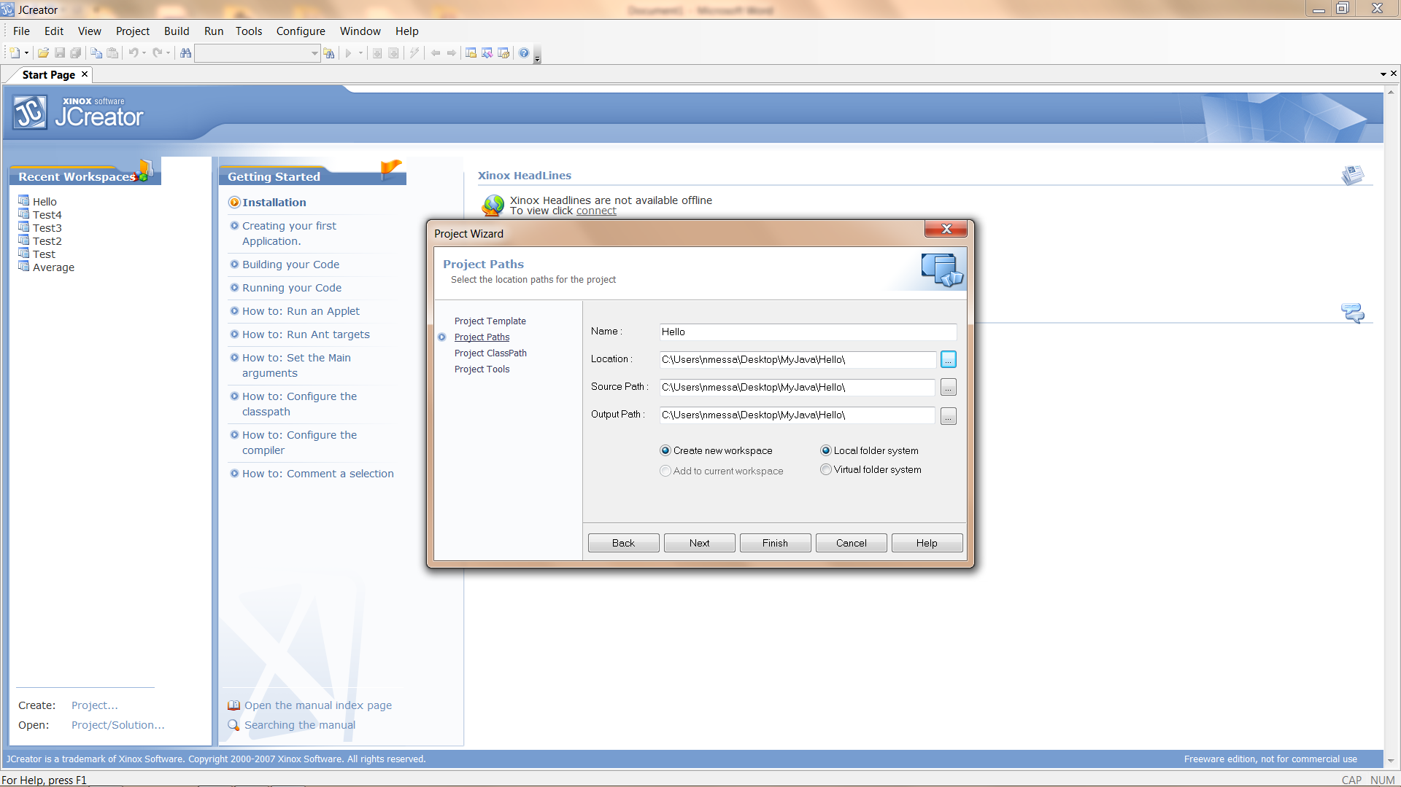

1. Click Next



1. Click Next



1. Click Finish



1. When the project has completed building, click Finish

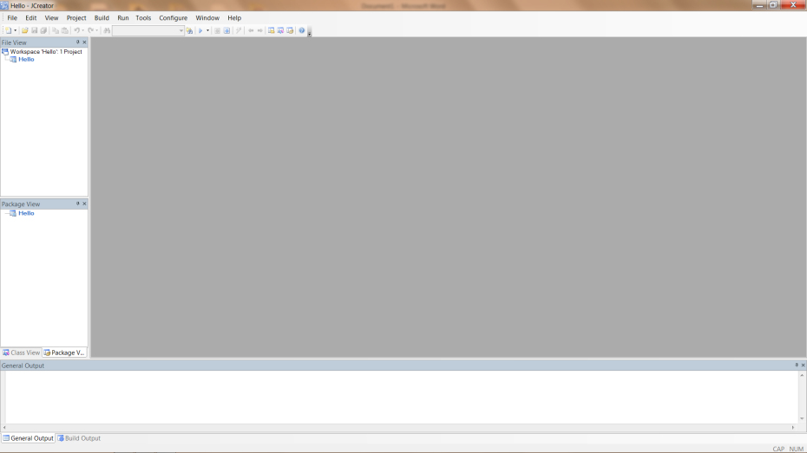

At this point we have an Empty Project. If you look inside the Hello folder (inside the MyJava folder) you will see 3 files (Hello.jcp, Hello.jcu, and Hello.jcw).

1. We will now add a file to our project by right-clicking on the project name and then Add|New File. This will open the File Wizard.

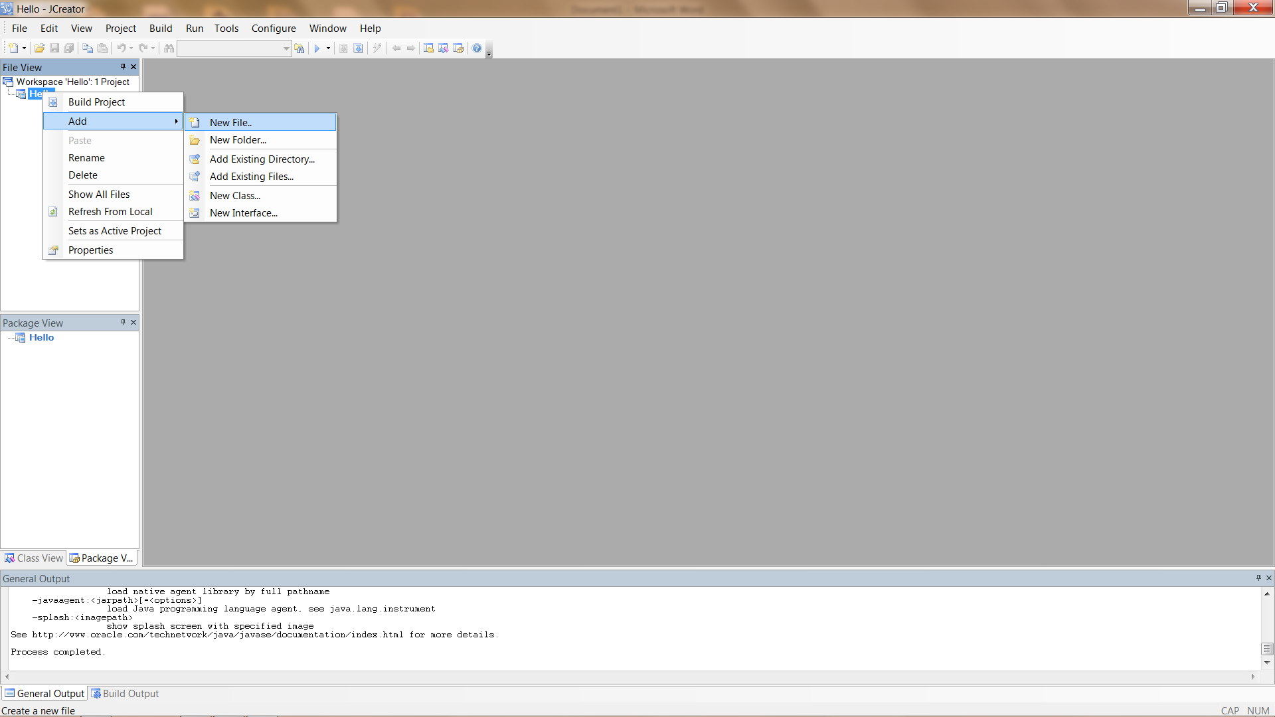

1. Select Main class and Next.

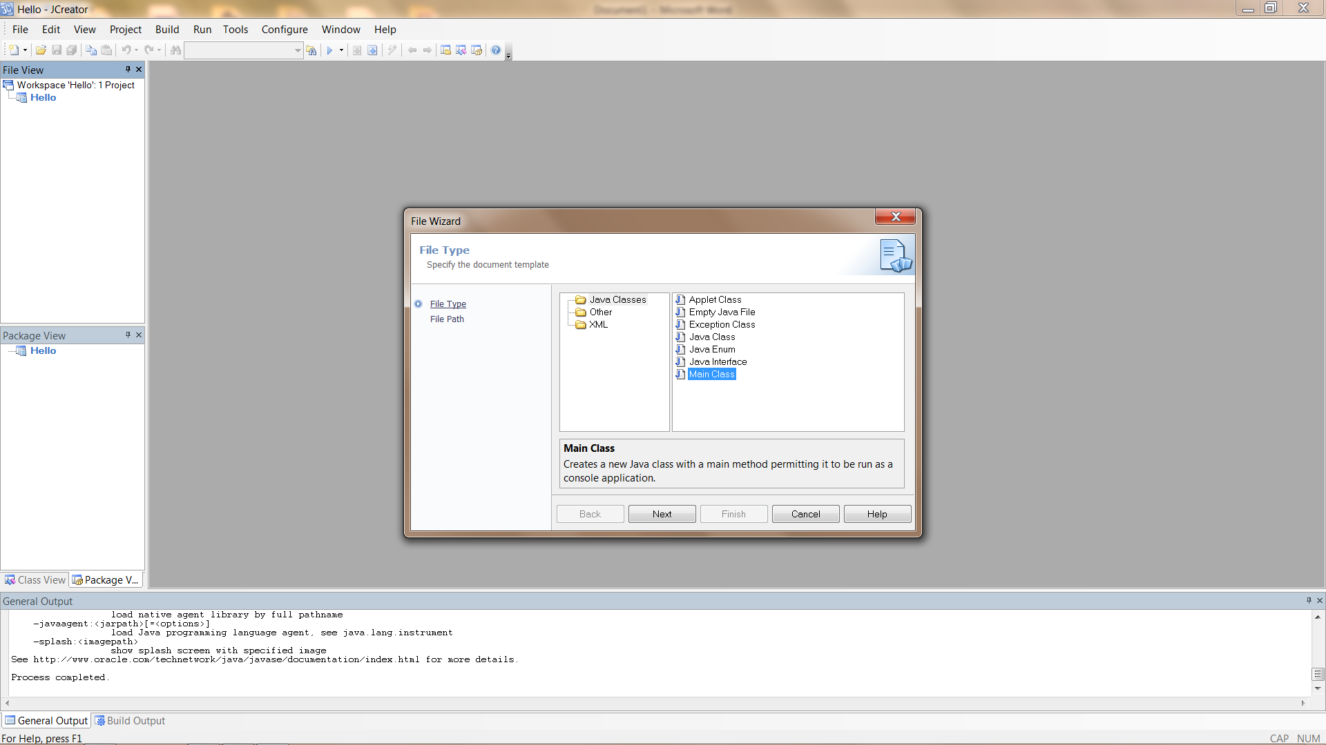

1. Give it a name of Hello.java and click Finish.

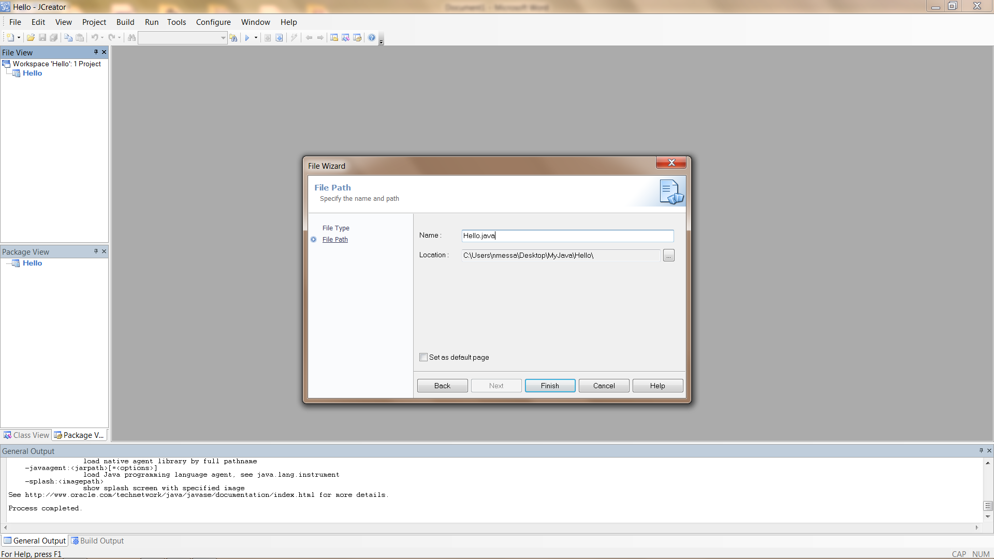

1. You will now have a source file which contains a class Hello. The class Hello contains a constructor method and a main method.

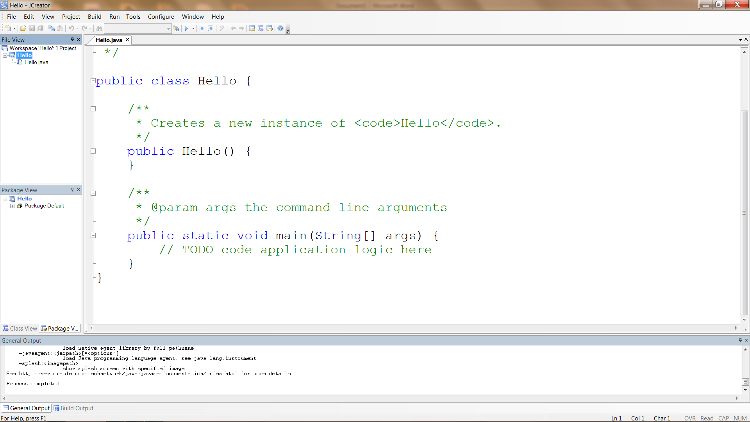

1. Click on the Run Project button and you should get a Process Complete message

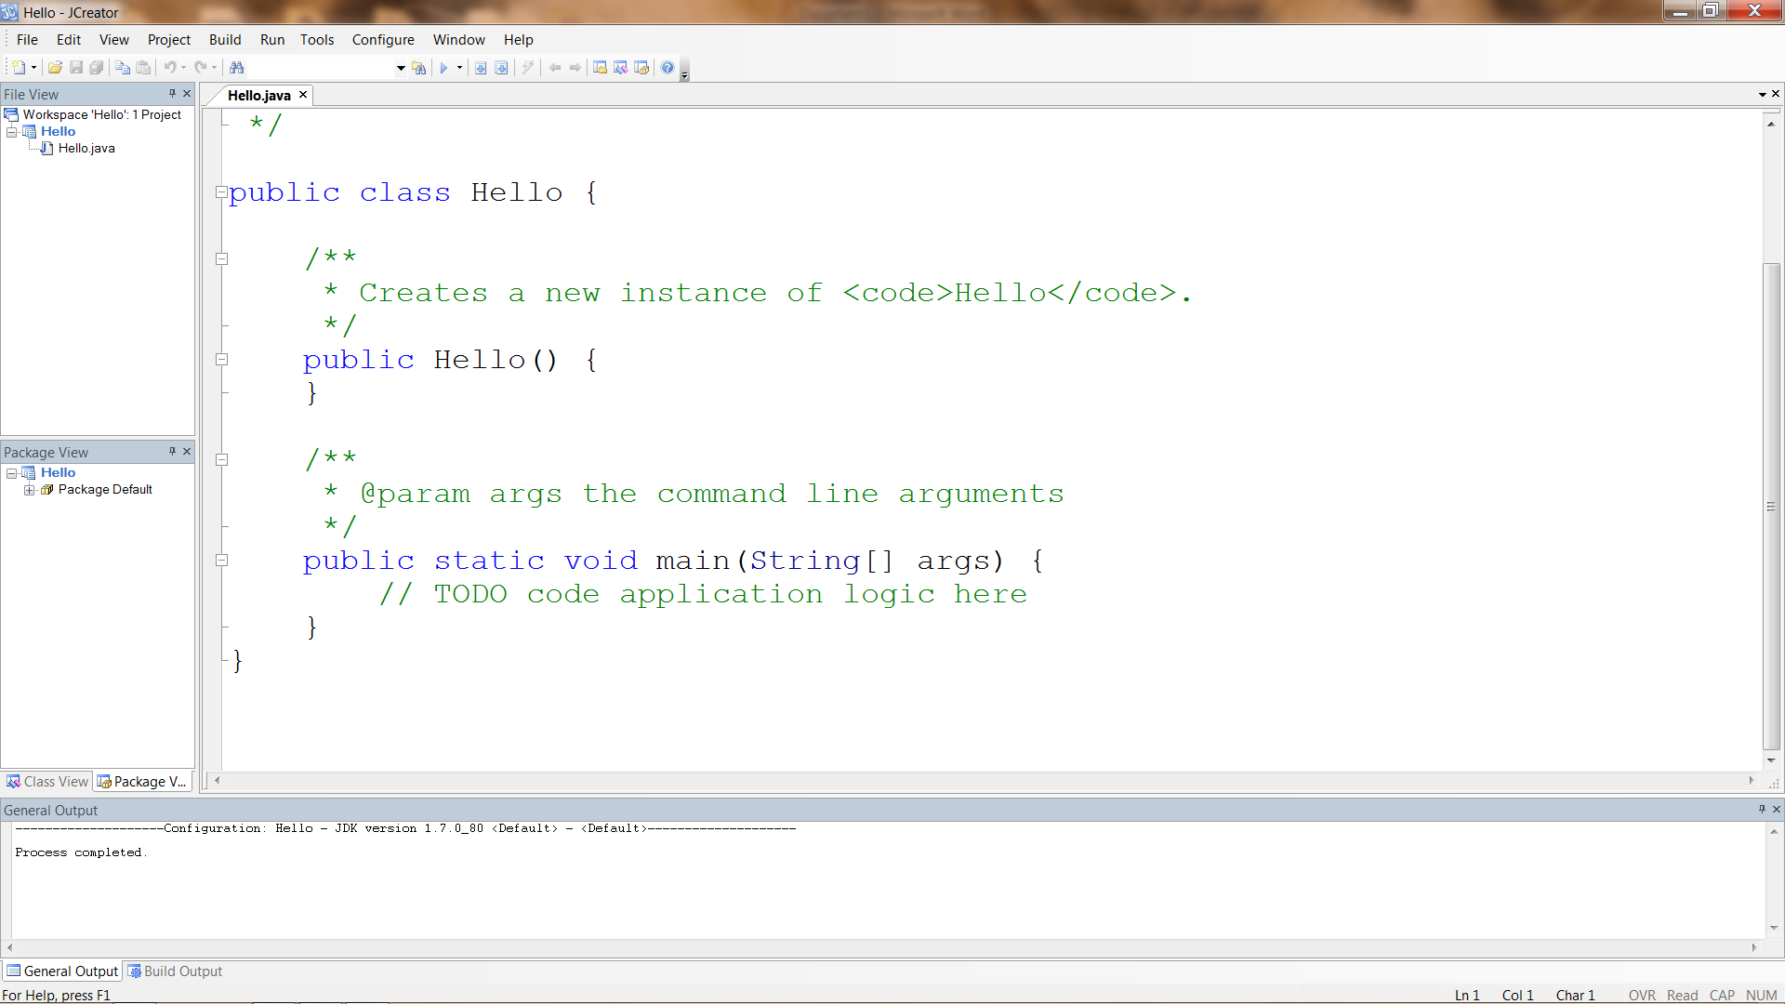

1. Now we will add code to the main method to print “Hello World!!!” to the console. Don’t forget the semicolon at the end of the line.

System.out.println("Hello World!!!");

After entering code, hit the Run Project button and you should see the “Hello World!!!” message in your console.

**Part I**

Top of Form

Top of Form

1. Complete the program so that it writes "Good-bye" on the computer monitor.

class Bye

{

public static void main ( String[] args )

{

System.out.println(" ");

}

}

Bottom of Form

Top of Form

2. The source file that this program is saved in should be called ______________ (Be sure you use correct upper and lower case characters.)

Bottom of Form

Top of Form

3. To compile the program, enter this command into the DOS window:

C:\SomeDir> ________________ Bye.java

Bottom of Form

Top of Form

4. The compiler will create a file containing _______________. This file will be named ____________________.

Bottom of Form

Top of Form

5. To run the bytecodes, enter this command into the DOS window:

C:\SomeDir> _______________ Bye

Bottom of Form

Top of Form

6. The program that interprets the byte codes on your hardware is called the Java _________________.

Bottom of Form

Top of Form

7. Although the underlying hardware may be different, the Java Virtual Machine on your computer is _________________ as that on any other computer, and so can run the same byte codes.

Bottom of Form

Top of Form

8. An _____________ is a Java bytecode program that runs on a Web browser.

Bottom of Form

Top of Form

9. To create a Java source file, use a program called a/an ______________ such as NotePad.

Bottom of Form

Top of Form

10. The command of DOS is used to examine the files in a directory _________.

**Part II**

Create a new project called FromMeToYou having a Tester class with the following content:

//Author: Your Name

//Date Created: 8.26.2014

public class Tester

{

public static void main(String args[])

{

//Todo: enter your code here

}

}

Enter your code that will produce the following:

From: William Henry Gates III

13 Mockingbird Lane

Redmond, WA 98052

To: Your name

Message: Help! I am stuck inside this computer being tortured by Windows ME.